Project Development Phase
Functional & Performance Testing
Date | 04 October 2026
Team ID | SWTID-2026-6870
Project Name | Streamlining IT Procurement: Automating Standard Laptop Orders with Flow Designer
Maximum Marks | Not specified

Test Scenarios & Results
The functional tests below cover each milestone of the project. Results are taken from the executed project steps and the screenshots captured in ServiceNow.
Test Case ID | Scenario (What to test) | Test Steps (How to test) | Expected Result | Actual Result | Pass/Fail
FT-01 | Flow creation | Flow Designer > New > Flow; enter name, Global, Run As System User; Submit | Flow "Standard laptop task" is created | Flow created and opened in Flow Designer | Pass
FT-02 | Trigger configuration | Add a trigger, search Service Catalog, select it, click Done | Service Catalog trigger saved on the flow | Trigger shows Service Catalog | Pass
FT-03 | Create Catalog Task action | Add action Create Catalog Task; set Requested Item, short description, Description, Assignment group, Approval | Action saved with all values | Table Catalog Task [sc_task] with Hardware and Approved values | Pass
FT-04 | Flow activation | Save the flow, click Activate, confirm | Flow status becomes Active | Flow shows Active | Pass
FT-05 | Flow assignment | Maintain Items > Standard Laptop > Process Engine; set Flow; Update | Catalog item uses the flow | Flow field shows Standard Laptop task | Pass
FT-06 | Order placement | Service Catalog > Hardware > Standard Laptop > Order Now | Request submitted with request number | "Thank you, your request has been submitted"; REQ0010001 | Pass
FT-07 | Request approval | Open request > Approvers; right-click record > Approve | Approval recorded for the request | Approver (Eric Schroeder) record approved | Pass
FT-08 | Catalog task generation | Open RITM0010001 > Catalog Tasks tab | Task created and assigned to Hardware | SCTASK0010001, Assignment group Hardware | Pass
FT-09 | Task field values | Open SCTASK0010001 | Short description, description and approval as configured | Short description and Description "Laptop needs to Configured"; Approval Approved | Pass
PT-01 | Task creation time | Compare order time with task start time | Task appears without manual action | Order placed 04:07:11; task actual start 04:11:40 (same day) | Pass
PT-02 | Multiple orders at the same time | Place several Standard Laptop orders together | One task per order, no failures | Not executed in this project run | Not tested

Test Evidence
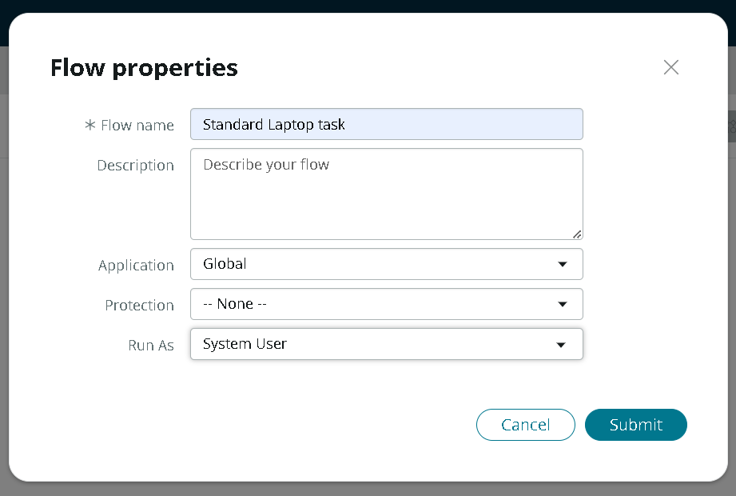
Figure 1: Flow properties (FT-01)
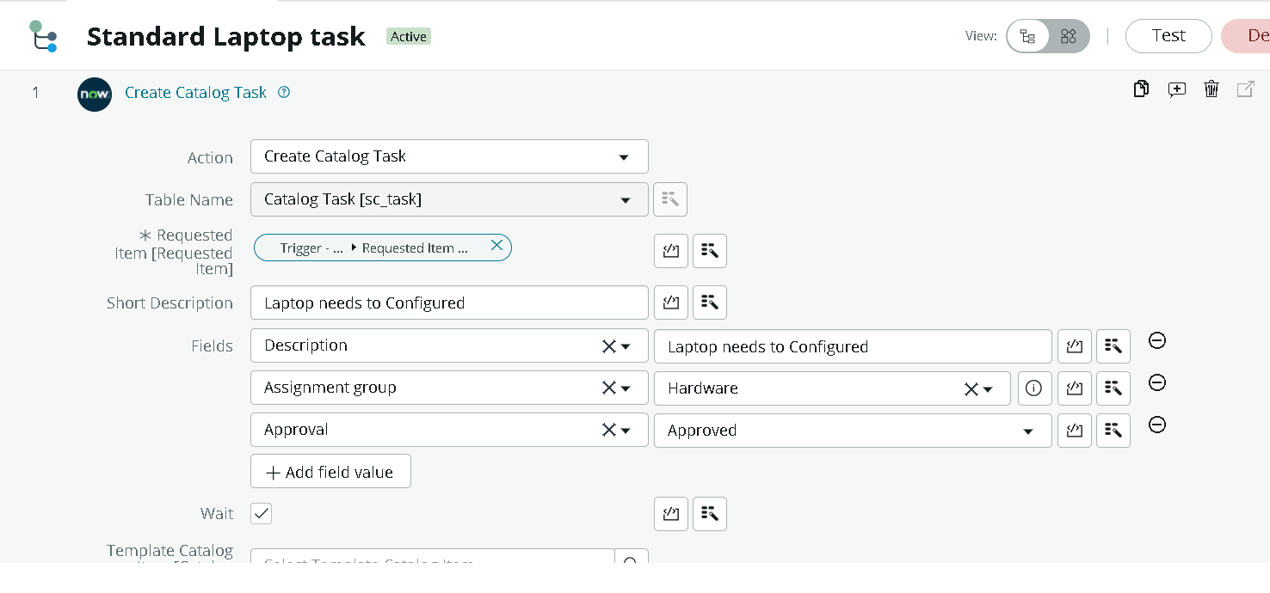
Figure 2: Create Catalog Task action configuration (FT-03)
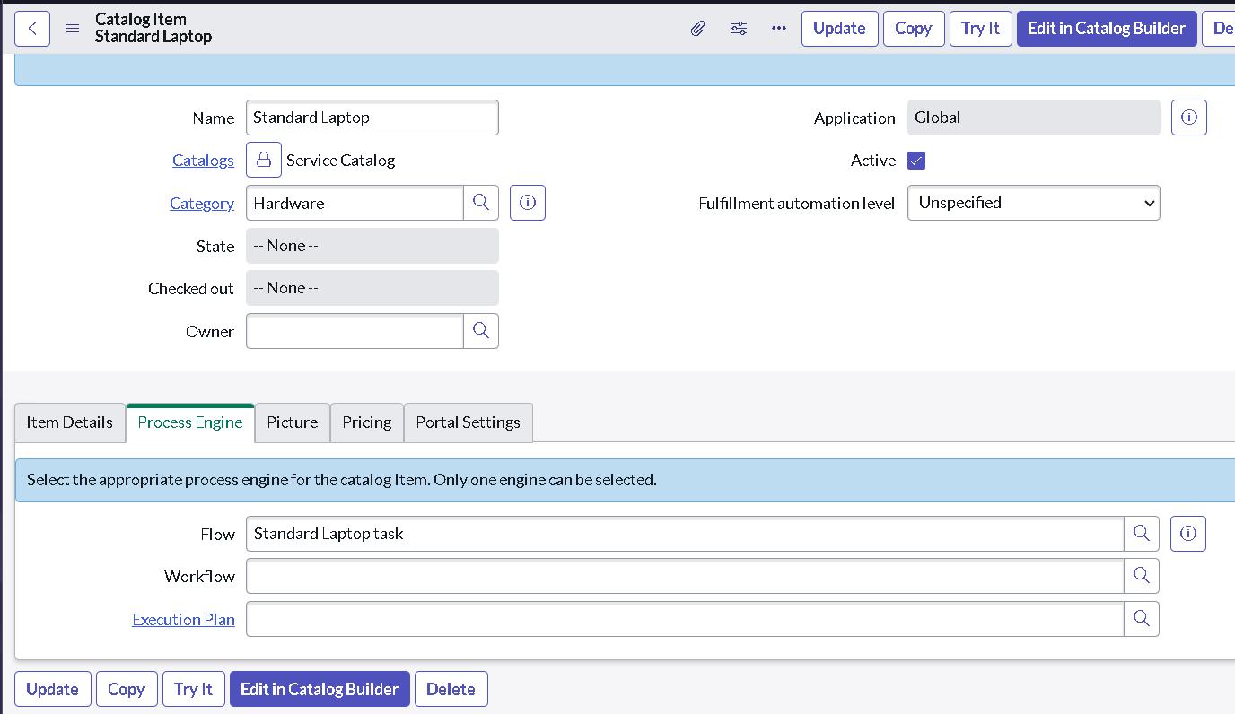
Figure 3: Flow attached in Process Engine (FT-05)
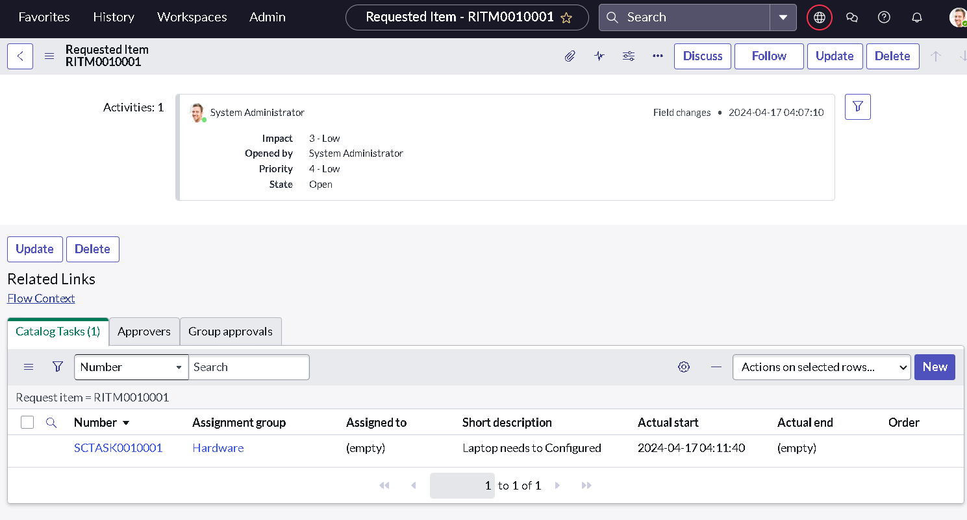
Figure 4: Catalog task generated under the Requested Item (FT-08)

